player (player_id, pname,speciality,date_of joining,num_matches,team_id)

create table player(

player_id int primary key,

pname varchar(30) not null,

speciality enum('baller','batsman','wicket keeper','all rounder'),

date_of_joining date,

num_matches int,

team_id int,

constraint fk_tid foreign key(team_id) references team(team_id)

on delete set null

on update cascade

);

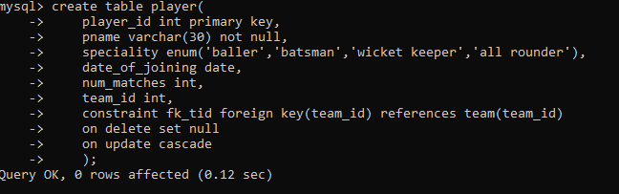

insert into team values(101,'RCB',13);

insert into team(team_id,tname,player_num) values

(102,'CSK',14),

(103,'MI',15),

(104,'RR',13);

team(team_id, tname,player_num)

create table team(

team_id int primary key,

tname varchar(30) not null,

player_num int check(player_num>10)

);

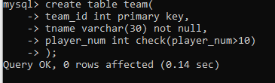

matches(match_id, team1_id,team2_id,match_date,winner,man_of_the match)

create table matches(

match_id int primary key,

match_date date,

winner int,

team1 int,

team2 int,

man_of_the_match int,

constraint fk_tid1 foreign key(team1) references team(team_id),

constraint fk_tid2 foreign key(team2) references team(team_id),

constraint fk_pid foreign key(man_of_the_match) references player(player_id),

constraint chk_win check(winner in(team1,team2))

);

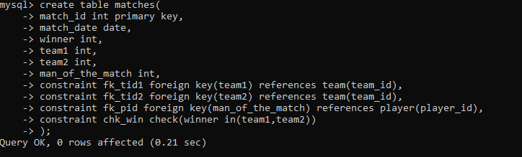

simple query

1. display all players playerid, player name and experience

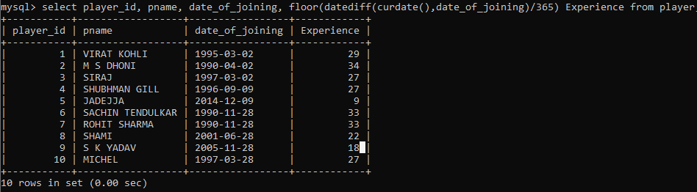

2. display all player with experience > 5 years

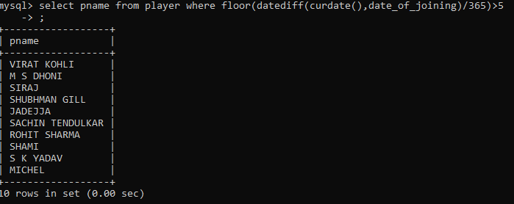

3. display all players joined in march month, any year

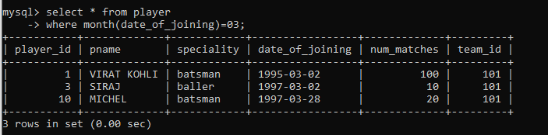

4. display all plaslectyers joined in march 1995

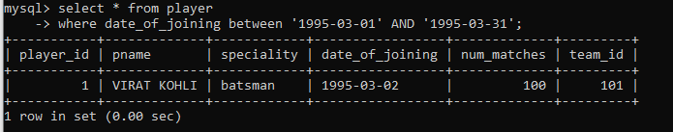

5. display all player with number of matches played are either 5 or 10 or 8

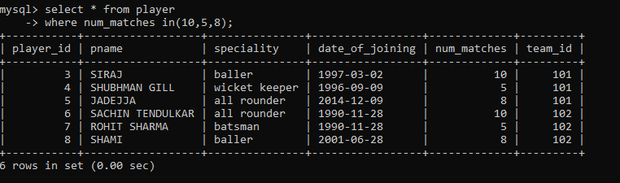

6. display all employees who are either batsman, bowler

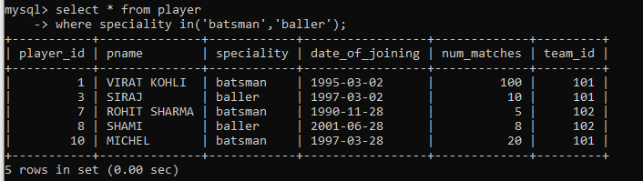

7. display all employees who joined in year 1995 or 1996 or 1997

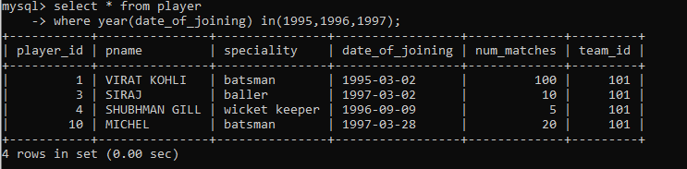

Nested query

1. list all player who plays in virat kohalis team

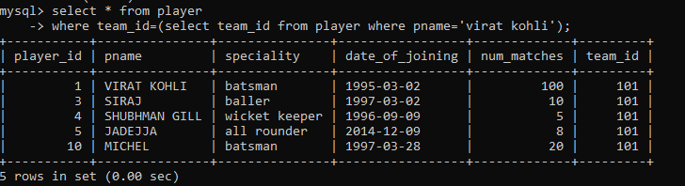

2. list all players who played matches in year 2024

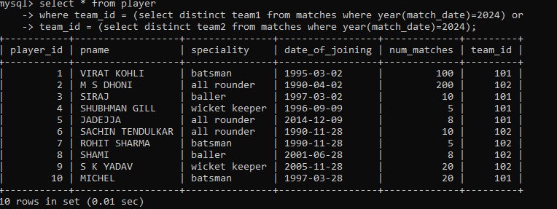

3. list all matches in which man of the match is from team1

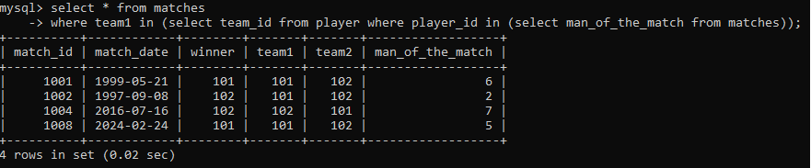

4. list all matches in which man of the match is from team1



5. list all matches in which csk team win.

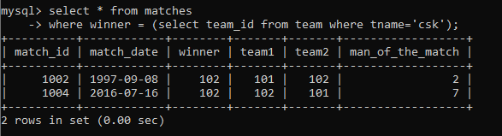

6. list all matches in which either csk or rcb team won the match

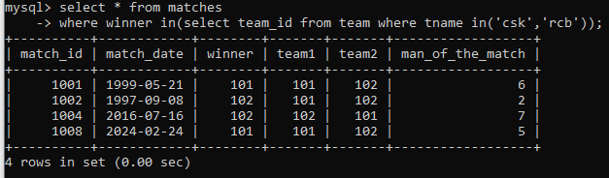

7. list all teams who won atleast one match

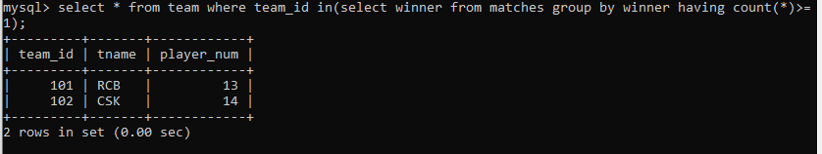

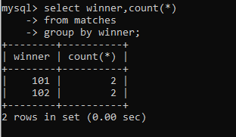

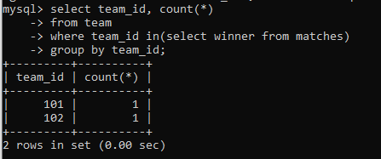

8. list all teams who does not played any match

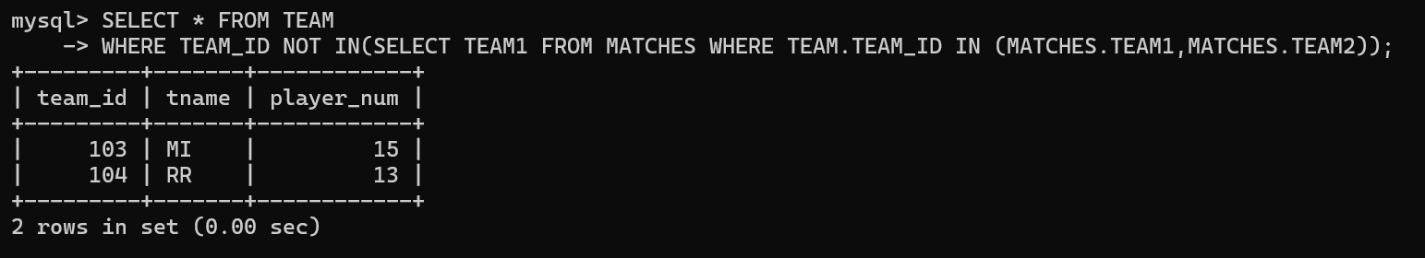

ANOTHER WAY 2

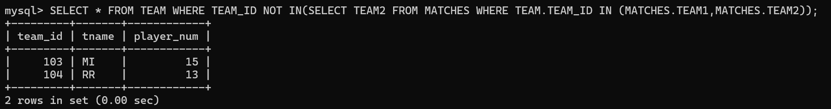

ANOTHER WAY 3

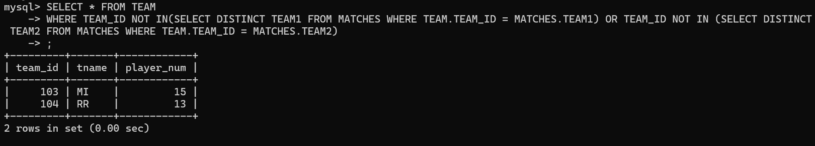

ANOTHER WAY 4

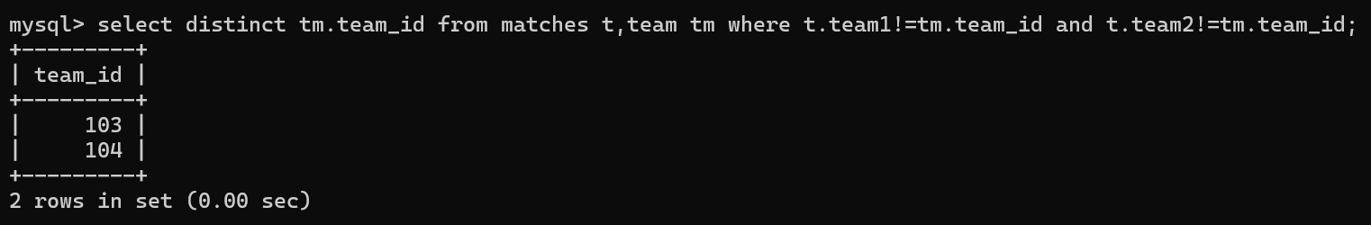

9. list all team name, in which no players are their

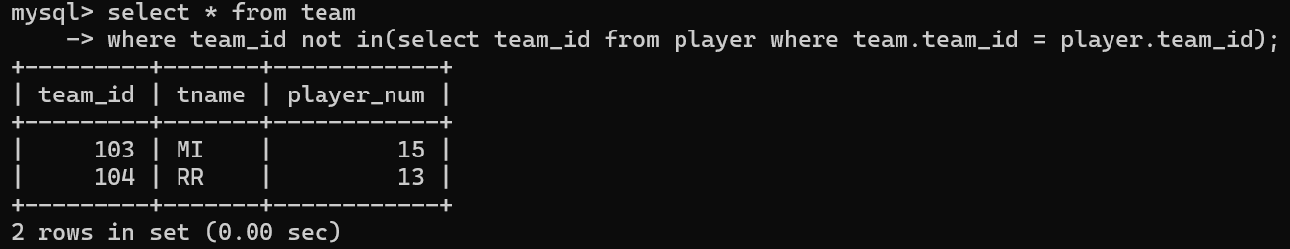

10. list all players who are in dhoni’s team

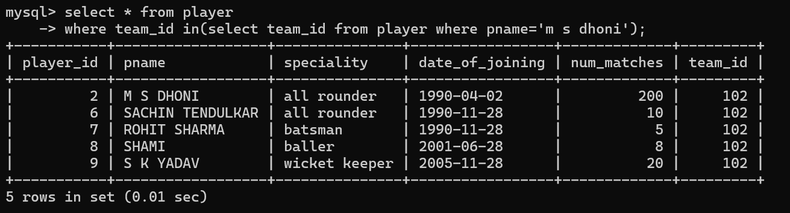

11. list all players who are in either dhoni’s or virat’s team

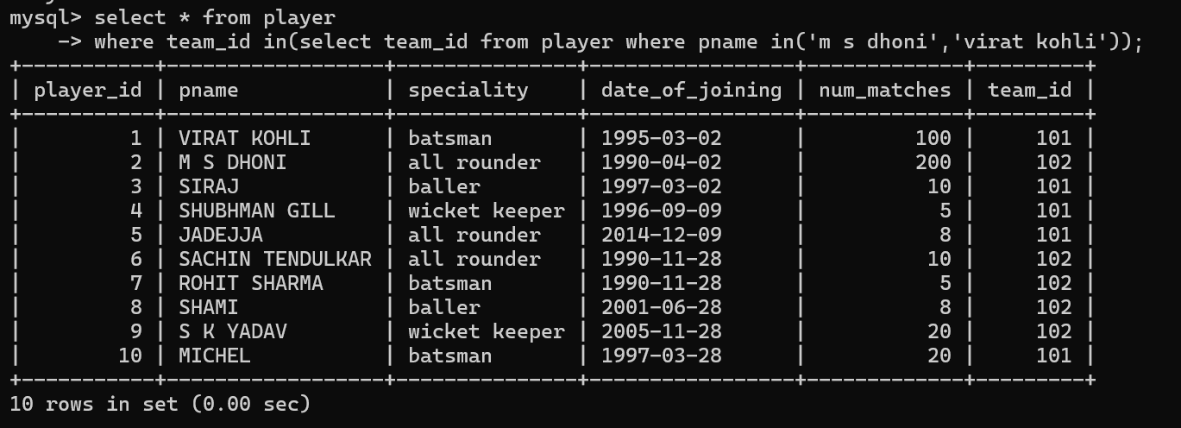

12. find all team names who won more than 3 matches

